IP 127.0.0.1

Internet based penetration test

Produced by:

Denys Shabelnyk  
ViA-KI-2022

18.05.2023

# 

# Table of contents

Legal notice 1

1. Table of contents 3

2. Management summary 5

3. Description of tested systems 6

4. Vulnerability categorization 7

4.1 Level 5 7

4.2 Level 4 7

4.3 Level 3 7

4.4 Level 2 8

4.5 Level 1 8

5. Identified vulnerabilities 9

5.1 Level 5 vulnerabilities 9

5.1.1 Weak passwords 9

5.1.2 Insufficient Authentication 9

5.1.3 Permanent Cross-site Scripting 10

5.1.4 OS Commanding 11

5.1.5 SSI Injection 11

5.1.6 Use of Vulnerable Software 12

5.2 Level 4 vulnerabilities 13

5.2.1 Weak Password Recovery Validation 13

5.2.2 Insecure Password Storage 14

5.2.3 Credential/Session Prediction 14

5.2.4 Insufficient Session Expiration 15

5.2.5 Session Fixation 15

5.2.6 Dynamic Cross-site Scripting 16

5.2.7 SQL Injection 16

5.2.8 Path Traversal 17

5.3 Level 3 vulnerabilities 18

5.3.1 Insufficient Authorization 18

5.3.2 Directory Indexing 19

5.3.3 Denial of Service 19

5.4 Level 2 vulnerabilities 20

5.4.1 Inconsistent Data Encoding 20

5.4.2 Information Leakage 20

5.4.3 Predictable Resource Location 21

5.4.4 Abuse of Functionality 21

5.4.5 Insufficient Anti-automation 22

5.4.6 Insufficient Error Handling 22

5.5 Level 1 vulnerabilities 23

5.5.1 Insufficient Process Validation 23

6. Appendix A. OSSTMM checklist 24

7. Appendix B. Testing protocols 29

8. Appendix C. OWASP ASVS checklist 31

# Management summary and description of tested system

The target is a remote host which has DNS name va03.z3.lv. The host is available through the Internet. The host is accept ICMP requests and has **TTL = 57**  
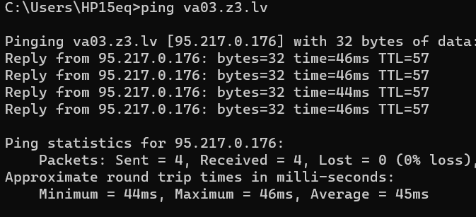

This value of TTL means that the target host **is not Windows machine**.

Next step, trying to get information from DNS name. If we use only free available tools from Internet we can get some useful information about **IP address** and where the target host **geographically located**. Let’s look at result from www.dnsqueries.com  
  
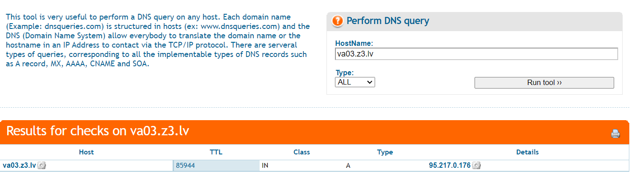  
The IP address is 95.217.0.176. This information can help us to know about internet service provider, about size of company, etc. Small companies use not wide range of Ips, but big companies do.   
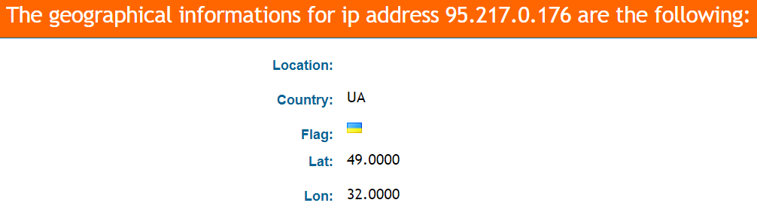  
If we look at GeoLocation we can know that the target post is located on Ukraine.

# 

The objective of current test was vulnerability assessment of the given host name va03.z3.lv. Testing was conducted during the time period from 18/05/2023 to 05/06/2023.

As I explored before, the target machine is not Windows machine. It has IP 95.217.0.176 and located in Ukraine

Interesting information gets **whois** about target IP  
  
**inetnum: 95.216.0.0 - 95.217.255.255**

**netname: DE-HETZNER-20090224**

**country: FI**

**org: ORG-HOA1-RIPE**

admin-c: HOAC1-RIPE

tech-c: HOAC1-RIPE

status: ALLOCATED PA

notify: ripe-mntner@hetzner.de

mnt-by: RIPE-NCC-HM-MNT

mnt-by: HOS-GUN

mnt-lower: HOS-GUN

mnt-domains: HOS-GUN

mnt-routes: HOS-GUN

created: 2009-02-24T07:39:38Z

last-modified: 2017-11-02T11:54:31Z

source: RIPE

abuse-email: abuse@hetzner.com

abuse-c: HOAC1-RIPE

abuse-org: ORG-HOA1-RIPE

organisation: ORG-HOA1-RIPE

org-name: Hetzner Online GmbH

country: DE

org-type: LIR

address: Industriestrasse 25

address: D-91710

address: Gunzenhausen

address: GERMANY

phone: +49 9831 5050

fax-no: +49 9831 5053

e-mail: info@hetzner.de

admin-c: MF1400-RIPE

admin-c: GM834-RIPE

admin-c: HOAC1-RIPE

admin-c: MH375-RIPE

admin-c: SK2374-RIPE

admin-c: SK8441-RIPE

abuse-c: HOAC1-RIPE

mnt-ref: RIPE-NCC-HM-MNT

mnt-ref: HOS-GUN

mnt-by: RIPE-NCC-HM-MNT

mnt-by: HOS-GUN

created: 2004-04-17T11:07:58Z

last-modified: 2022-11-22T18:32:44Z

source: RIPE

role: Hetzner Online GmbH - Contact Role

address: Hetzner Online GmbH

address: Industriestrasse 25

address: D-91710 Gunzenhausen

address: Germany

phone: +49 9831 505-0

fax-no: +49 9831 505-3

e-mail: ripe@hetzner.com

abuse-mailbox: abuse@hetzner.com

remarks: *************************************************

remarks: * For spam/abuse/security issues please contact *

remarks: * abuse@hetzner.com, or fill out the form at *

remarks: * abuse.hetzner.com, thank you. *

remarks: *************************************************

remarks:

remarks: *************************************************

remarks: * Any questions on Peering please send to *

remarks: * peering@hetzner.com *

remarks: *************************************************

org: ORG-HOA1-RIPE

admin-c: MH375-RIPE

tech-c: GM834-RIPE

tech-c: SK2374-RIPE

tech-c: MF1400-RIPE

tech-c: SK8441-RIPE

tech-c: DD15478-RIPE

nic-hdl: HOAC1-RIPE

notify: ripe-mntner@hetzner.com

mnt-by: HOS-GUN

created: 2004-08-12T09:40:20Z

last-modified: 2022-11-22T18:33:55Z

source: RIPE

route: 95.216.0.0/16

org: ORG-HOA1-RIPE

descr: HETZNER-DC

origin: AS24940

mnt-by: HOS-GUN

created: 2017-08-12T12:01:36Z

last-modified: 2018-01-10T08:47:33Z

source: RIPE

organisation: ORG-HOA1-RIPE

org-name: Hetzner Online GmbH

country: DE

org-type: LIR

address: Industriestrasse 25

address: D-91710

address: Gunzenhausen

address: GERMANY

phone: +49 9831 5050

fax-no: +49 9831 5053

e-mail: info@hetzner.de

admin-c: MF1400-RIPE

admin-c: GM834-RIPE

admin-c: HOAC1-RIPE

admin-c: MH375-RIPE

admin-c: SK2374-RIPE

admin-c: SK8441-RIPE

abuse-c: HOAC1-RIPE

mnt-ref: RIPE-NCC-HM-MNT

mnt-ref: HOS-GUN

mnt-by: RIPE-NCC-HM-MNT

mnt-by: HOS-GUN

created: 2004-04-17T11:07:58Z

last-modified: 2022-11-22T18:32:44Z

source: RIPE

Whois gets information about domain name owner, its juridical address.  
Also, whois shows us information about IP range in section **inetnum.**   
This information is taken us ability to perform port scanning on particular range.

There are no result on public databases like **Bing.com** and **Shodan.io** with filters **:ip** and **:net**

# Vulnerability categorization

|  |  |  |
| --- | --- | --- |
| **Level** | **Severity** | **Description** |
| 5 | Urgent | Trojan Horses; file read and writes exploit; remote command execution |
| 4 | Critical | Potential Trojan Horses; file read exploit |
| 3 | High | Limited exploit of read; directory browsing; DoS |
| 2 | Medium | Sensitive configuration information can be obtained by hackers |
| 1 | Low | Information can be obtained by hackers on configuration |

## Level 5

Level 5 vulnerabilities provide remote intruders with remote root or remote administrator capabilities. With this level of vulnerability, hackers can compromise the entire host. Level 5 includes vulnerabilities that provide remote hackers full file-system read and write capabilities, remote execution of commands as a root or administrator user. The presence of backdoors and Trojans also qualify as Level 5 vulnerabilities. In case of web applications, full access to sites administration (CMS – content management system, for example) is also considered Level 5 vulnerability.

## Level 4

Level 4 vulnerabilities provide intruders with remote user, but not remote administrator or root user capabilities. Level 4 vulnerabilities give hackers partial access to file-systems (for example, full read access without full write access). Vulnerabilities that expose highly sensitive information qualify as Level 4 vulnerabilities. In case of web applications, access to other user account is also considered Level 4 vulnerability.

## Level 3

Level 3 vulnerabilities provide hackers with access to specific information stored on the host, including security settings. This level of vulnerabilities could result in potential misuse of the host by intruders. Examples of Level 3 vulnerabilities include partial disclosure of file contents, access to certain files on the host, directory browsing, disclosure of filtering rules and security mechanisms, susceptibility to denial of service (DoS) attacks, and unauthorized use of services such as mail relaying.

## Level 2

Level 2 vulnerabilities expose some sensitive information from the host, such as precise versions of services. With this information, hackers could research potential attacks against a host.

## Level 1

Level 1 vulnerabilities expose information, such as open ports, or other sensitive information from the host that does not qualify as Level 2 vulnerability.

# Identified vulnerabilities

## Level 5 vulnerabilities

### Weak passwords

|  |
| --- |
| **Description** |
| Users will often choose easy to guess passwords, possibly found in a dictionary, if choosing weak passwords is permitted by application. Given this scenario, an attacker would try thousands or potentially millions of guesses searching for the valid password. In case of strong passwords attacker would need to try billions of guesses what typically can not be performed in a reasonable amount of time. When a guessed password allows access to the system, the attack has been successful and the attacker is able access the account. |
| **System** |
|  |
| **Sample** |
|  |
| **Recommendations** |
| An adequate password policy should be created after risk assessment. Users should be informed about this policy and aspects of these requirements. In order for the password policy to be effective it has to be technically enforced, by not allowing use of passwords which do not match sites password policy. |

### Insufficient Authentication

|  |
| --- |
| **Description** |
| Insufficient Authentication occurs when a web site permits an attacker to access sensitive content or functionality without having to properly authenticate. Web-based administration tools are a good example of web sites providing access to sensitive functionality. Depending on the specific online resource, these web applications should not be directly accessible without the user required to properly verify their identity. |
| **System** |
|  |
| **Sample** |
|  |
| **Recommendations** |
| To get around setting up authentication, some resources are protected by “hiding” the specific location and not linking the location into the main web site or other public places. However, this approach is nothing more than “Security Through Obscurity”. It’s important to understand that simply because a resource is unknown to an attacker; it still remains accessible directly through a specific URL. The specific URL could be discovered through a Brute Force probing for common file and directory locations (/admin for example), error messages, referrer logs, or perhaps documented in help files. **These resources, whether they are content or functionality driven, should be adequately protected.**  Sometimes resources are not planned to be directly accessed; are not necessary for site functionality or have been set up for temporary use. However, they usually tend to be left accessible for indefinite time and their functionality abused. **Therefore temporary resources should be protected at a production level; unnecessary files removed and direct access allowed only to specified resources.** |